**Topic #6:**

**Behavior of Gases &**

**Gas Laws**

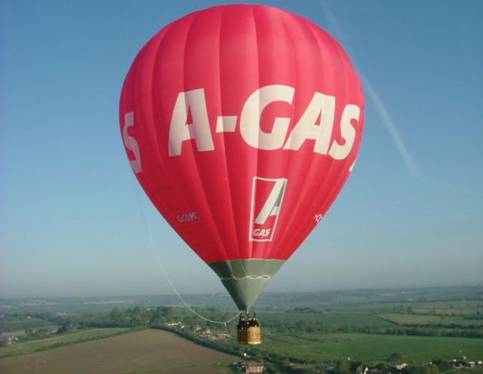

Textbook Chapters 13 & 14

(pg. 420-424; pg. 448-485)

**Homework Due:** Wednesday, December 9

**Exam - Free Response:** Friday, December 11

**Exam - Multiple Choice:** Monday, December 14

Student Study Guide: Topic #6 - Behavior of Gases and Gas Laws

Temperature

* Temperature is a measure of the average kinetic energy of the particles.
* Common temperature scales include Celsius and Kelvin (or Absolute).
  + Kelvin is used in all Gas Laws formulas because temperatures on the Kelvin scale are directly proportional to the average kinetic energy of the particles. Celsius temperatures are not.
* Absolute zero (0 Kelvin) is the theoretical temperature at which no molecular motion exists.

Vapor pressure

* Vapor pressure is defined as the pressure exerted by a gas over its liquid or solid phase.
* Vapor pressure is dependent only on temperature (see Chart H) (*not* pressure, amount of substance present, etc.)
* Substances with weak intermolecular forces of attraction (IMFA) have high vapor pressures, and evaporate easily. Substances that evaporate easily are called *volatile*.
* Substances with strong IMFA have low vapor pressures and do *not*  evaporate easily since these attractive forces must be overcome to form the gas phase.

Standard Temperature and Pressure (Reference Table A)

* STP is defined as:
  + Temperature: 0oC or 273K
  + Pressure:
    - 1 atmosphere (atm)
    - 101.3 kilopascals (kPa)
    - 760 torrences (torr)
    - 760 millimeters of mercury (mmHg)

Kinetic Molecular Theory of Gases

1. Gases consist of tiny particles (atoms or molecules).
2. These particles are extremely small compared with the distances between them; the volume (size) of individual particles can be assumed to be negligible (zero).
3. Gas particles are in constant, random motion, colliding with the walls of their container. These collisions with the walls cause the pressure exerted by the gas. Collisions result in a transfer of energy although the average kinetic energy does not change as long as the temperature is constant (i.e., collisions are said to be "elastic.")
4. Gas particles are assumed not to attract or repel each other.
5. The average kinetic energy of the gas particles is directly proportional to the Kelvin temperature of the gas.

Gas Laws (check schematic diagram included in the study guide)

BOYLE CHARLES GAY-LUSSAC AVOGADRO

P x V = k V/T = k P/T = k V/moles = k

inverse direct direct direct

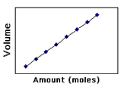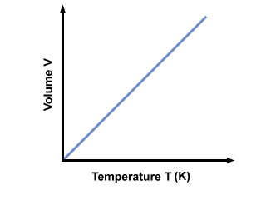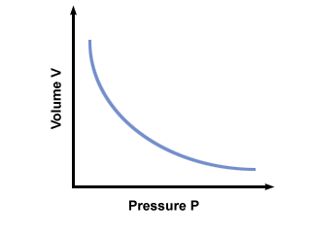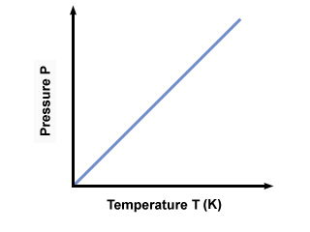

Graham’s Law of Diffusion

* Graham's Law of Diffusion states that the rate of diffusion of a gas has an inverse relationship to the mass or density of the gas.
* The *greater the mass* or density of the gas, the *slower* the gas will diffuse.
* The lower the mass or density of a gas the faster the gas will diffuse.

Calculating Density of a Gas:

* Density (g/L) = molar mass(g) / 22.4 (L)

Dalton’s Law of Partial Pressure

* Dalton's Law of Partial Pressure states that for a mixture of gases in a container, the total pressure exerted is the sum of the partial pressures of the gases present.
* Partial pressure of a gas is the pressure that the gas would exert if it were alone in the container.
* Ptotal = P1 + P2 + P3  .........
* Total pressure / total moles = pressure per mole

Combined Gas Law (Reference Table T)



* By removing the factor that is constant a formula is obtained to solve for either Boyle, Charles or Gay-Lussac’s Law.

Ideal Gas Law

* By combining the laws of Boyle, Charles and Avogadro, we can show how the volume of a gas depends on pressure, temperature and number of moles present.
* Ideal Gas Law equation: PV = nRT

P = pressure V = volume n = number of moles R = universal gas constant (0.08206 L atm / K mol) and T = temperature in Kelvin

* A gas that obeys this equation is said to behave ideally under conditions of high temperature, low pressure and low mass when particles do not attract or collide.

KEY VOCABULARY

STP vapor pressure temperature

absolute zero Kelvin Celsius

density real gas ideal gas

collision direct relationship inverse relationship

diffusion partial pressure Kinetic Molecular Theory

Ideal Gas Law

Combined Gas Law

Boyle’s Law

Charles’ Law

Gay-Lussac’s Law

Avogadro’s Law

Graham’s Law of Diffusion

Dalton’s Law of Partial Pressure

**STUDENT HOMEWORK PACKET**

Topic #6: Behavior of Gases & Gas Laws

**Section A – Kinetic Molecular Theory (KMT) and Properties of Gases**

1. Use your textbook to state the three assumptions of the kinetic theory as it applies to gases (pg. 420).

a) _______________________________________________________________________________________

__________________________________________________________________________________________

b) _______________________________________________________________________________________

c) _______________________________________________________________________________________

2. Define “gas pressure” (pg. 421).

__________________________________________________________________________________________

__________________________________________________________________________________________

3. Describe the relationship between atmospheric pressure and altitude. Explain.

__________________________________________________________________________________________

__________________________________________________________________________________________

4. Complete the following pressure conversions. SHOW ALL WORK.

a) Convert 385 mmHg to atmospheres.

b) Convert 385 mmHg to kilopascals.

c) Convert 3.2 atmospheres to kilopascals.

Textbook Page 454:

#1: ______________________________________________________________________________________

__________________________________________________________________________________________

#2: ______________________________________________________________________________________

#3: ______________________________________________________________________________________

__________________________________________________________________________________________

#4: ______________________________________________________________________________________

Textbook Page 463:

#17: _____________________________________________________________________________________

#18: _____________________________________________________________________________________

#19: _____________________________________________________________________________________

#22: ______

**Section B - Combined Gas Law Calculations**

**Instructions**: Complete the following problems. For each problem, state the name of the law used and show all work, including correct formula, substitution with units and final answer with proper units. Put a box around your final answer.

1. Submarines need to be strong to withstand the extremely high pressure of water pushing down on them. An experimental research submarine with a volume of 15,000 liters has an internal pressure of 1.2 atm. If the pressure of the ocean breaks the submarine forming a bubble with a pressure of 250 atm pushing on it, how big will that bubble be? Assume temperature is constant.

Name of Law _____________________________

1. The temperature inside a refrigerator is about 4.0o C. If a balloon with an initial temperature of 22o C and a volume of 6.5 liters was placed into the refrigerator, what will the volume be when the balloon is completely cooled to the internal temperature assuming the pressure is constant.

Name of Law _____________________________

1. An aerosol can at room temperature (25oC) contains gas under 2.3 atm of pressure. The can was left in the sun for 2 hours and reached a temperature of 55oC. What is the new pressure inside the can. The volume of the can does not change.

Name of Law _____________________________

Explain why there is “CAUTION” not to exceed 55oC temperature on all aerosol cans.

__________________________________________________________________________________________

__________________________________________________________________________________________

4. An unknown volume of a gas has a pressure of 52.5 kPa and a temperature of 325 K. The pressure is raised to 121 kPa, the temperature is decreased to 320 K and the final volume of the gas was computed to be 48.0 L. What was the initial volume of the gas?

Prediction:

* The change in temperature from ________ to ________ will cause the volume of the gas to __________________ (increase or decrease).
* The change in pressure from ________ to ________ will cause the volume of the gas to _____________________( increase or decrease).

Calculation using Combined Gas Law:

Does your answer make sense with your prediction? ________________

Textbook Page 480:

#56: ______________

#60: ______________

Textbook Page 481:

#79: _____________________________________________________________

#80: _____________________________________________________________________________________

__________________________________________________________________________________________

#81: _____________________________________________________________________________________

__________________________________________________________________________________________

**Section B – Vapor Pressure of Four Liquids (Reference Table H)**

1. What is the vapor pressure of ethanol at 75oC? __________________________
2. At what temperature is the vapor pressure of water 101.3 kPa? __________________
3. Identify the substance that has the strongest intermolecular forces of attraction.

______________________________________

4. Explain how the boiling point temperature is affected as the atmospheric pressure of a substance increases.

______________________________________________________________________________________

______________________________________________________________________________________

______________________________________________________________________________________

5. Describe why the vapor pressure of a liquid changes with an increase in temperature.

______________________________________________________________________________________

______________________________________________________________________________________

**Section C – The Ideal Gas Law**

Ideal Gas Law

1. According to section 13.5 on page 415, what characteristics of a gas does the Ideal Gas Law involve?

_____________________________________________________________________________________

1. The formula for the Ideal Gas Law is PV = nRT. What does each stand for?

P = ________________________ n = _______________________

V = ________________________ R = _______________________

T = _______________________

1. This equation defines the behavior of an ideal gas. What does “ideal” refer to?

______________________________________________________________________________________

______________________________________________________________________________________

Textbook Page 468:

#31: _____________________________________________________________________________________

#32: ____________

#33: ____________

#34: _____________________________________________________________________________________

__________________________________________________________________________________________

Textbook Page 480:

#63: _____________________________________________________________________________________

__________________________________________________________________________________________

**Section E – Dalton’s Law of Partial Pressures & Graham’s Law of Diffusion**

1. Suppose you have two 1-L flasks, one containing N2 at STP, the other containing CH4 at STP. How do these systems compare with respect to the following:

1. number of molecules ______________________________________________________________

_______________________________________________________________________________________

B) density ____________________________________________________________________________

_______________________________________________________________________________________

1. average kinetic energy of the molecules ____________________________________________

_______________________________________________________________________________________

1. rate of diffusion through a pinhole __________________________________________________

_______________________________________________________________________________________

2. A) A 2.0 liter sample of oxygen gas is saturated with water vapor at 27oC. The total pressure of the mixture is 772 torr, and the vapor pressure of water is 26.7 torr at this temperature. What is the partial pressure of the oxygen gas?

B) Name of Law ___________________________

1. What is the pressure of the oxygen gas in atmospheres?

D) *Going Ahead:* Using the **Ideal Gas Law**, how many moles of oxygen are there in the sample of oxygen?

PV = nRT

Textbook Page 474:

#40: _____________________________________________________________________________________

__________________________________________________________________________________________

#41: _____________________________________________________________________________________

__________________________________________________________________________________________

#43: ____________________

#45: _____________________________________________________________________________________

__________________________________________________________________________________________

Textbook Page 481:

#89: _____________________________________________________________________________________

__________________________________________________________________________________________

__________________________________________________________________________________________

**Pearson SuccessNet On-Line**

**1. Go to: Chapter 14 🡪 Chapter-Level Activities 🡪 Ch. 14 A Fresh Look At Fruit 🡪 Watch Video.**

**2. Go to: Chapter 14 🡪 Chapter-Level Activities 🡪 14.4 Kinetic Art: Partial Pressure of Gases. Answer all questions and submit.**

**Reading in the Sciences Assignment**